**Practical No-13**

**Aim** : Association Rule Mining.

**Solution** : Choosing Association Scheme Click ‘Associate’ tab at the top of ‘WEKA Explorer’ window. It brings up interface for the Apriori algorithm. 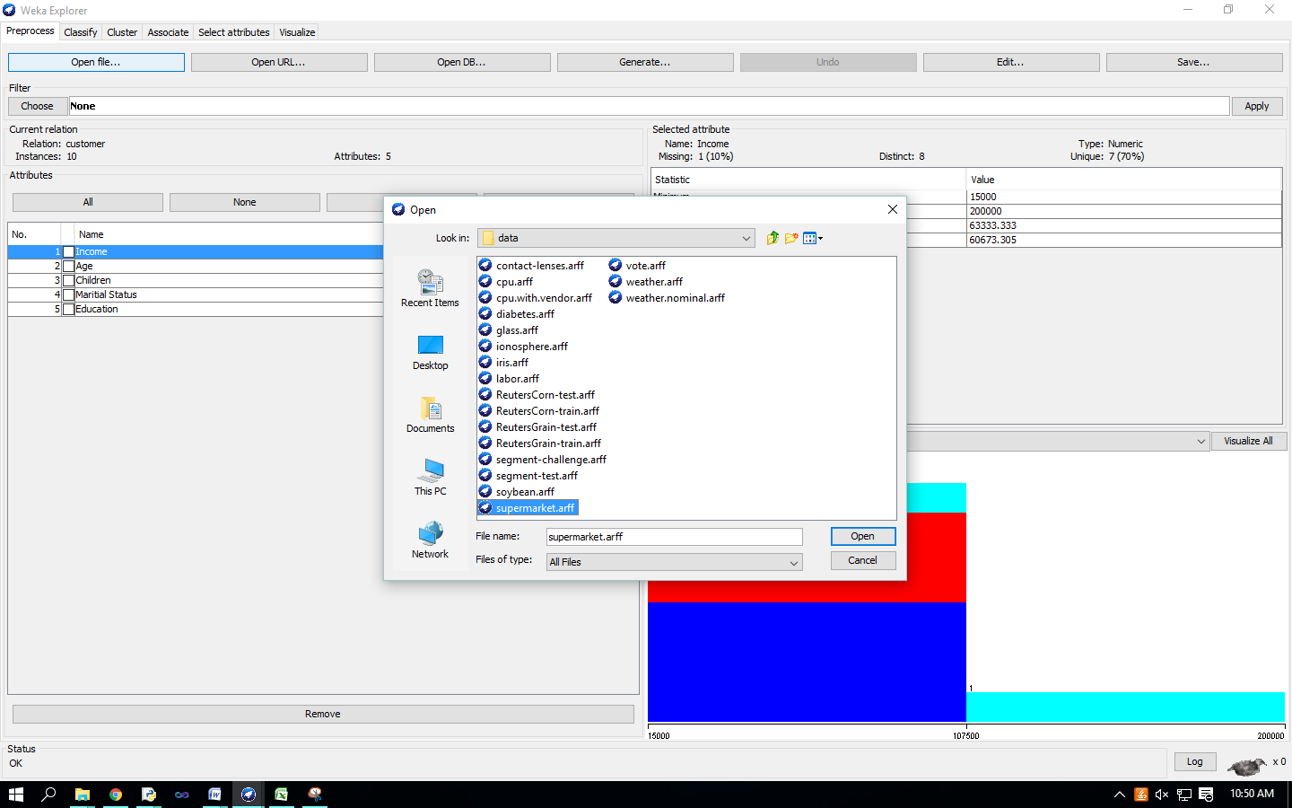

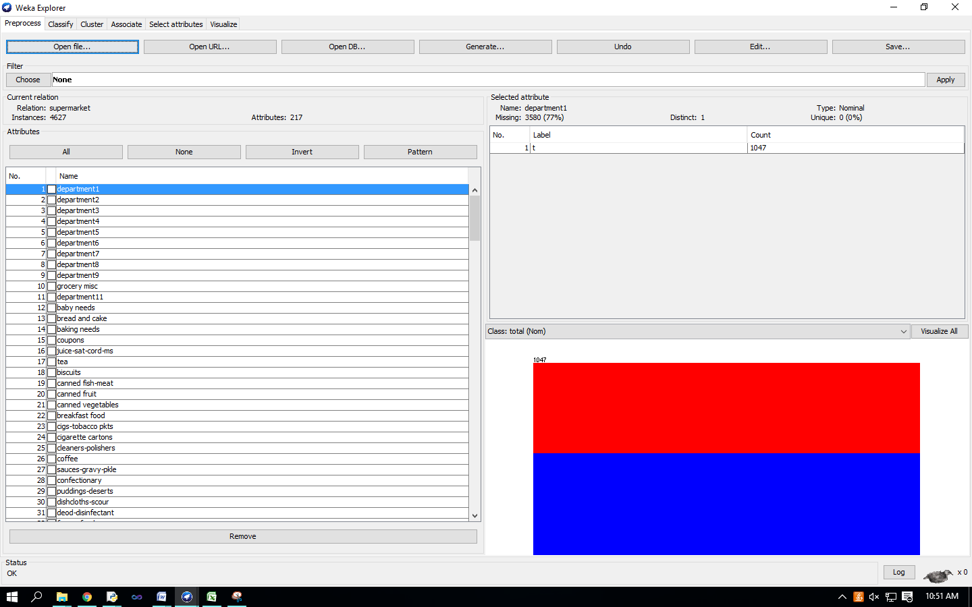 Setting Test Options

Check the text field in the ‘Associator’ box at the top of the window

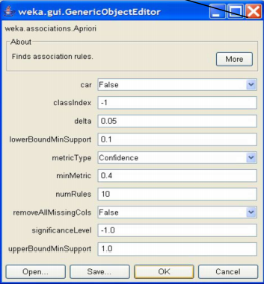

Right-click on the ‘Associator’ box, ‘GenericObjectEditor’ appears on your screen Click on the ‘Start’ button to execute the algorithm